Package Usage

The whole interview process takes about 2 hours and it can vary depending on the duration and number of breaks and interruptions. The chart shows identifiers of each resource and can be used as a guideline for reproducing the interview process, in both face-to-face and remote settings.
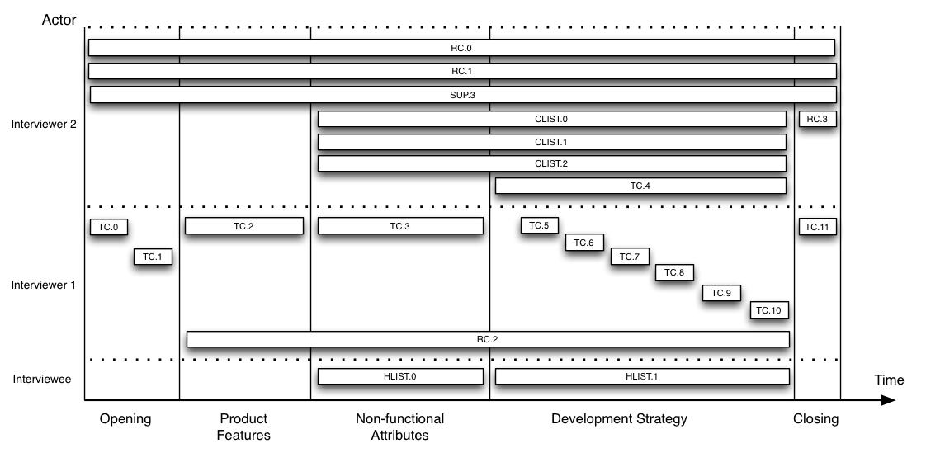
The time axes has been divided in five distinct phases with different concerns (detailed in the Table 1), while the vertical axes separates the competences of each actor involved.
The Interviewer 1 is in charge of conducting the interview asking questions and following the scripts (Topic Cards), while the Interviewer 2 has supervisory responsibilities such as :

- monitoring and updating the status and execution time of each step;
- writing notes as the interview proceeds;
- monitoring the audio recordings of the conversation;
- taking snapshots of the whiteboard.
- monitoring the concepts being covered, in case of something important is skipped;
- adjust intervention of Interviewer 1.

During the process it is important that the Interviewer 1 actually drives the interview through different thematic areas and covers all relevant topics, but at the same time providing the interviewee with the possibility to move across different concepts with a reasonable degree of freedom. Observe that during the phases P3 and P4 the interviewee can support her answers skimming through lists of well-known Quality Attributes (HLIST.1) and SE artifacts (HLIST.2).

We executed the interview process several times, and from the experience we gained, we found optimal to have a ten minutes break between P3 and P4 to quickly review partial results and adjust the direction towards the next phases.

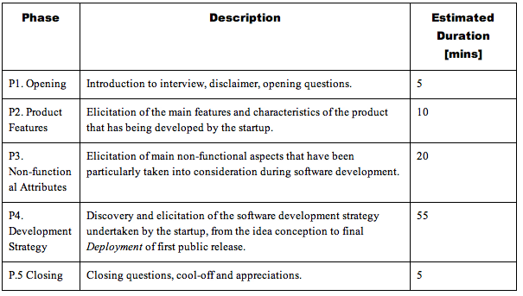
Pre-Interview Check-List

- Print Package Usage
- Deploy package in ~/Interview/Execution/<companyName>
- Gather information about the company and fill SUP.3
- Print Topic-Cards
- Print Notes (RC.2)
- Print HLISTs
- Print CLISTs
- Prepare Prezi
- Add Interviewee on skype/g+
- Prepare Google Hangouts
- Prepare Audio Recordings
- SoundCheck
- Run a small simulation
- iPad with Timer ready
- Organize all the paper resources on table
- Close useless applications

Post-Interview Check-List

- Send Thank you Email
- Take pictures
- Update SUP.3
- Print SUP.3
- Check Audio Recordings
- Immediately Write a report
- Extract a list of Tools / Frameworks / Artifacts / Trade-offs / Documents
- Customize Follow-up
- Change hang-out password
- Save it
- Try it
- Send it
- Wait for answers
- Send Prizes list

